1. What are the advantages of Bootstrap?

* Responsiveness
* Consistency
* Browser Compatibility
* JS plugins
* Customizable
* Great Grid System
* Easy to use
* Community Support
* Mobile First
* Avoid Repetitive actions
* Quick designs of prototype

1. What is a Bootstrap Container, and how does it work?

* Containers are the most basic layout element in Bootstrap and are required when using our default grid system. Containers are used to contain, pad, and (sometimes) center the content within them. While containers can be nested, most layouts do not require a nested container.

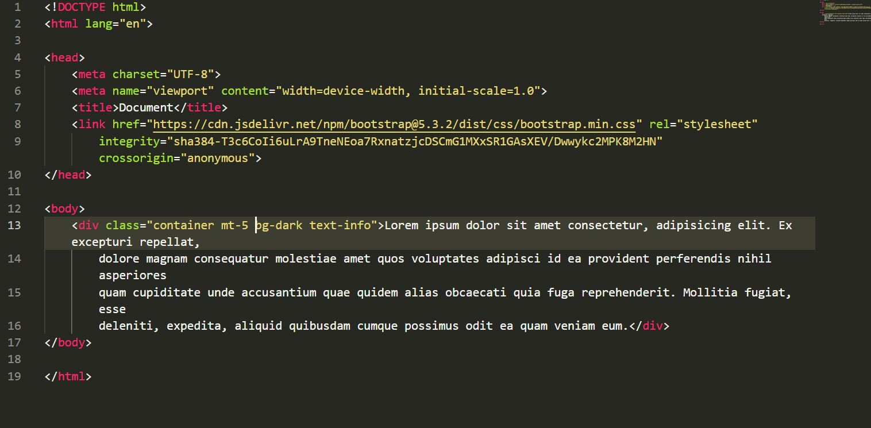

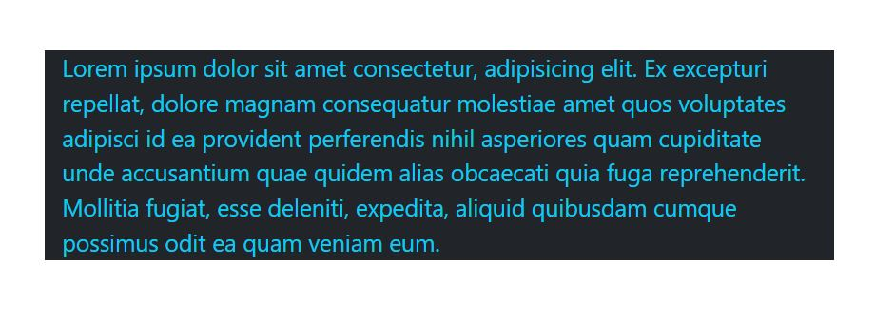

1. What are default Bootstrap text settings?

* Bootstrap 5's default text settings are:
* Font-size: 1rem (16px)
* Line-height: 1.5
* Margin-top and margin-bottom: 0 and 1rem (16px) for all <p> elements
* background-color is **#fff**(white) by default.
* Bootstrap 5 uses the browser's default root font-size and a "native font stack" that selects the best font-family for each OS and device. You can change these values to suit your own project.

1. What do you know about the Bootstrap Grid System?

* Bootstrap’s grid system uses a series of containers, rows, and columns to layout and align content. It’s built with [flexbox](https://developer.mozilla.org/en-US/docs/Web/CSS/CSS_Flexible_Box_Layout/Using_CSS_flexible_boxes) and is fully responsive. Below is an example and an in-depth look at how the grid comes together.
* While Bootstrap uses ems or rems for defining most sizes, pixels are used for grid breakpoints and container widths. This is because the viewport width is in pixels and does not change with the [font size](https://drafts.csswg.org/mediaqueries-3/#units).

|  | **Extra small** <576px | **Small** ≥576px | **Medium** ≥768px | **Large** ≥992px | **Extra large** ≥1200px |
| --- | --- | --- | --- | --- | --- |
| **Max container width** | None (auto) | 540px | 720px | 960px | 1140px |
| **Class prefix** | .col- | .col-sm- | .col-md- | .col-lg- | .col-xl- |
| **# of columns** | 12 | | | | |
| **Gutter width** | 30px (15px on each side of a column) | | | | |
| **Column ordering** | Yes | | | | |

* See how aspects of the Bootstrap grid system work across multiple devices with a handy table.

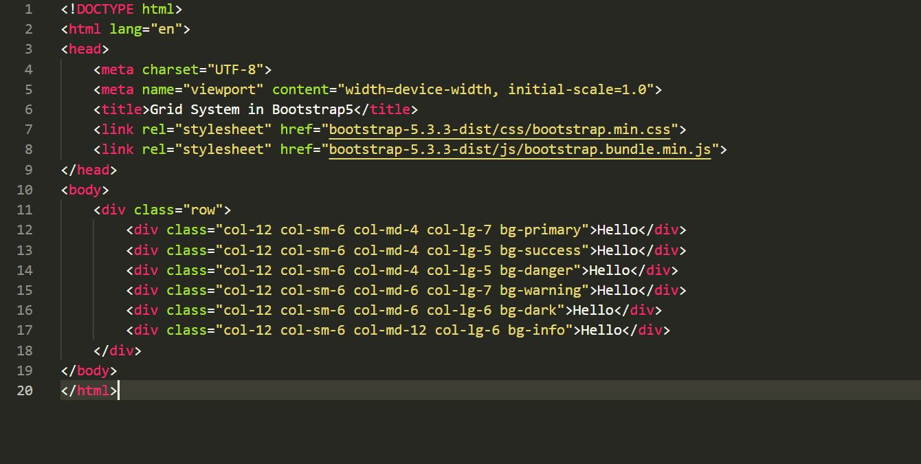

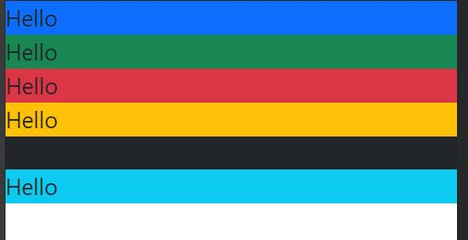

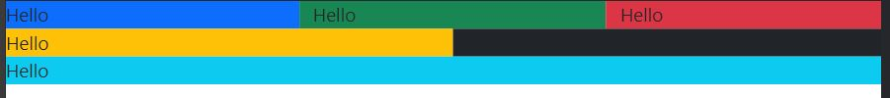



1. What is the difference between Bootstrap 4 and Bootstrap 5 ?

|  |  |  |
| --- | --- | --- |
| Property | BS 4 | BS5 |
| Grid System | It has 5 sizes (xs,sm,md,lg,xl) | It has 6 sizes (xs,sm,md,lg,xl,xxl) |
| Color | It has limited colors | Extra colors has been added to the palette |
| JQuery | It has jquery and all related plugin | JQuery is removed and switched to vanilla JS |
| IE | It supports both IE 10 and IE 11 | It doesn’t support IE 10 and IE 11 |
| Form | Radio buttons, checkboxes have different looks in different browsers and OS | Whether it may be due to different OS or browsers it will not change form of form elements |
| Utilites API | We cannot modify the utilities in BS 4 | BS 5gave freedom to modify and also create our own utility |

1. What is a Button Group, and what is the class for a basic Button Group?

* Bootstrap allows you to group a series of buttons together (on a single line) in a button group:

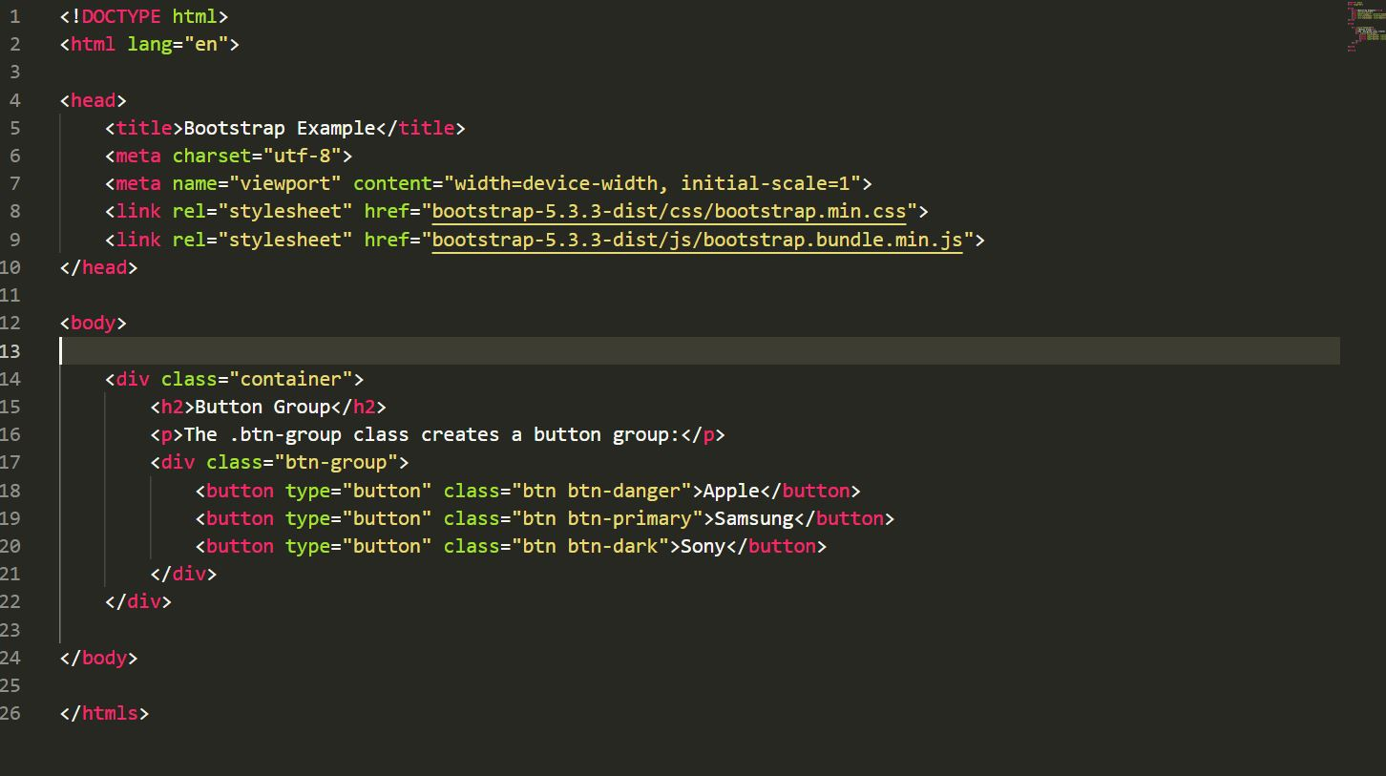

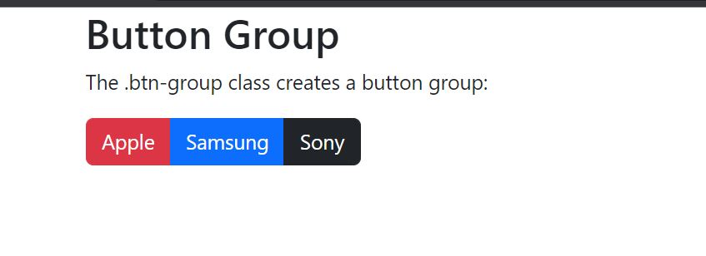

1. How can you use Bootstrap to make thumbnails?

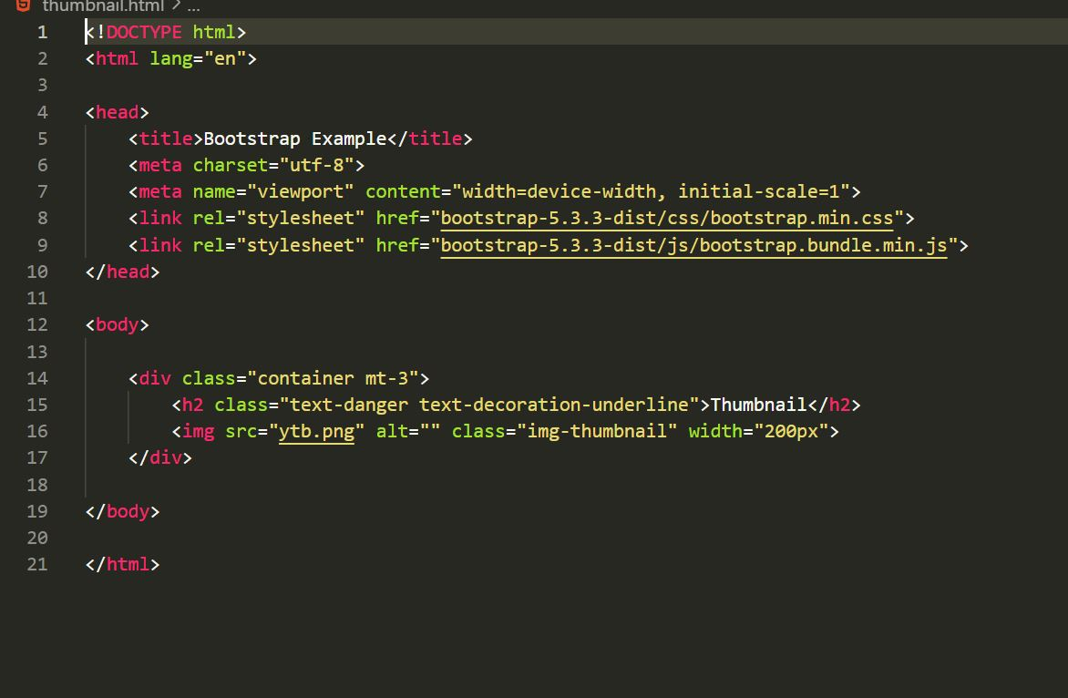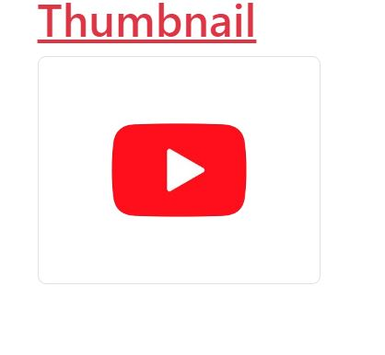

1. In Bootstrap 4, what is flexbox?

* Flexbox is used to handle layouts in HTML document in the BS 4.
* The Flexible Box Layout Module, makes it easier to design flexible responsive layout structure without using float or positioning.

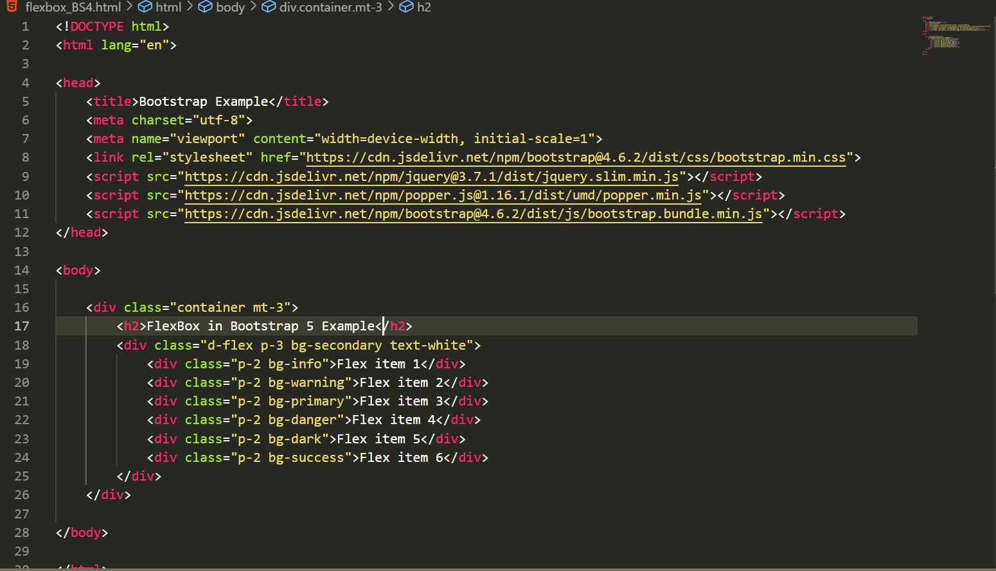

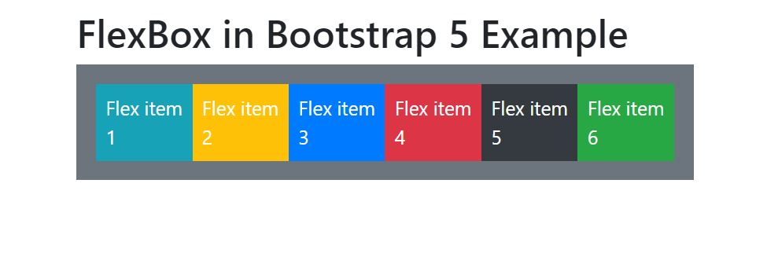

1. How can one create an alert in Bootstrap? 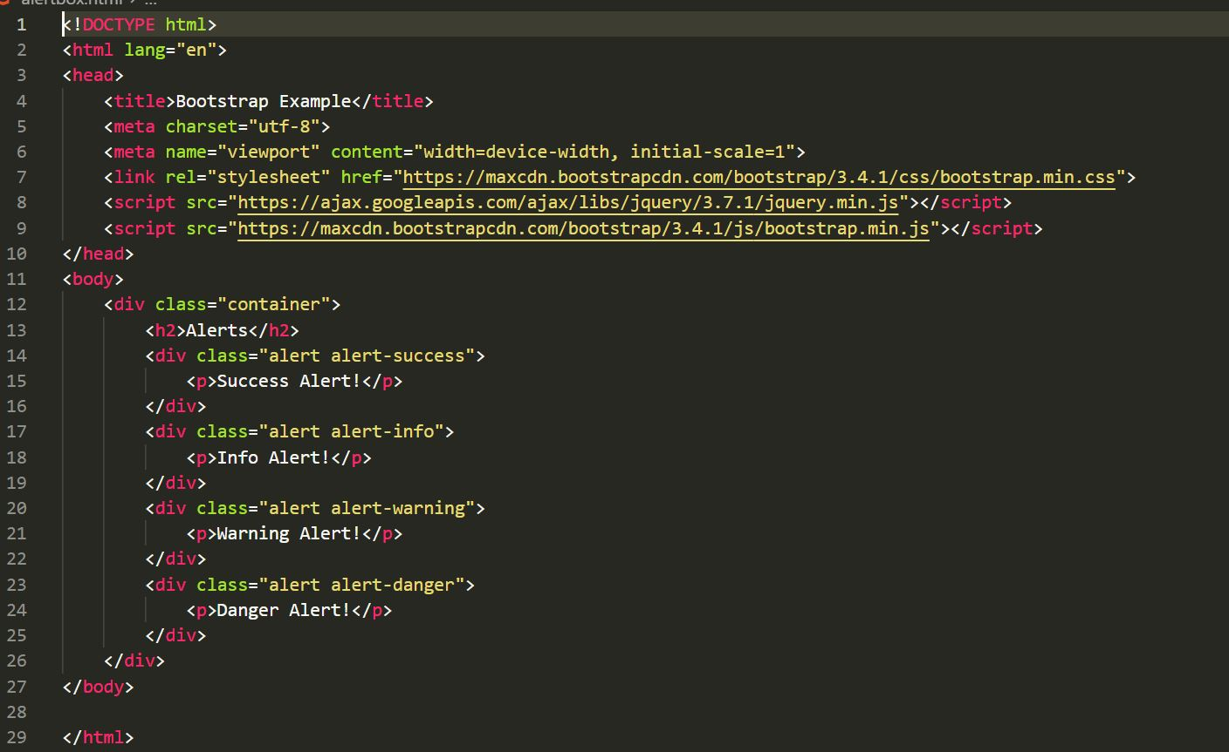

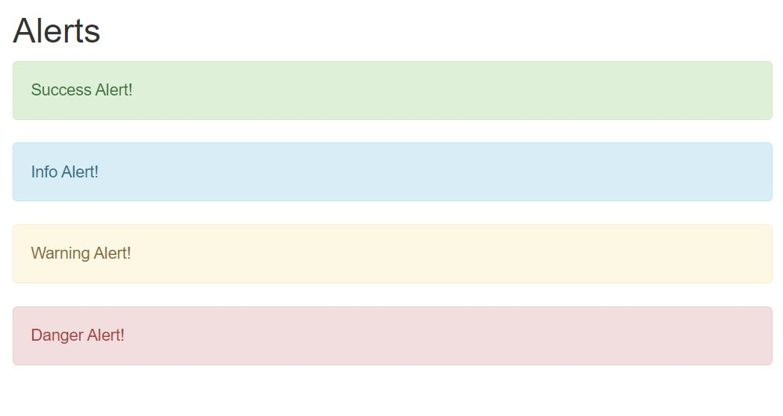

1. What is a bootstrap card and how would you create one?

